CS405 HW1 Report

Kaan Bilgili 27983

The dataset that I used for this homework is “Kaba intihar hızı”. The dataset has statistics of years 2022-1975 but, I only have years 2022-2011 in my visualization. I keep the data in a static array.

(Years 2004-2010 are commented out but they would get drawn if they were not commented out)

The x-axis, y-axis, the ticks for x-axis and the labels for the x-axis are created as such. The only element that is not static here is the y-axis.

I don’t have a JavaScript file but instead I wrote the script codes inside the html file. In that script part I have a function that creates bars in the bar chart. 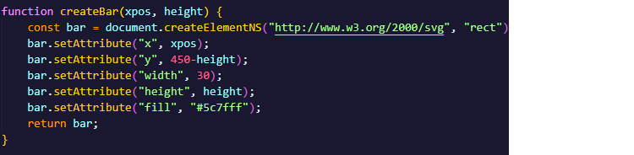

The xpos value is dependent on the index of the year. The height value is dependent on the number of suicides in that particular year. I set the “y” of the new elements in accordance with their height.

Then for every year, I create a year label, a tick in between labels, and I also create a text that displays the value and I put this text inside the bar.

Here I create the year label for every input.

Here I create the ticks in between the labels.

Here I create the texts that appear inside the bars. I use the “transform“ attribute to rotate the numbers.



Here I elongate the y-axis for every input.

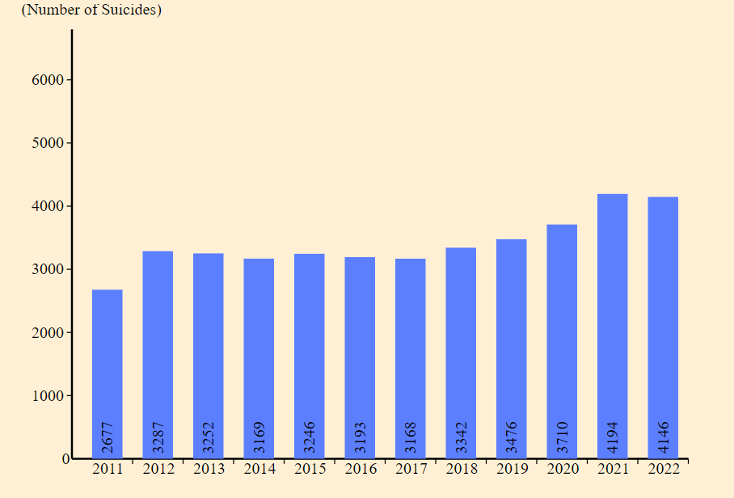

This here is the visualization I get when I comment out the years 2004-2010.

And this here is the bar chart visualization of the suicide numbers of years 2004-2011.